- We expect UK net inward migration will dip below 100,000 this year – the lowest level since 1997. The political climate suggests net inflows will stay low for at least the remainder of the current parliament that ends in 2029.
- If the trend holds, the cumulative impact of lower immigration means the UK population will be 1.5mn (2.1%) lower than the official principal projection in 2030.
- If the official forecast from the Office for Budget Responsibility moves into line with ours, that would cut its projection for the level of potential output in 2029-2030 by 1ppt. This implies that government borrowing would be £19bn (0.5% of GDP) higher, wiping out most of the Chancellor's headroom. The OBR could cut its migration assumptions in this autumn's Budget.
- The UK's ageing population means that potential output growth must rely less on increasing labour supply and more on productivity gains. We're hopeful that advances in AI can help the UK improve its productivity growth eventually, but not as much as the OBR assumes.
Since the global financial crisis, a collapse in productivity growth in the UK has resulted in much weaker GDP growth. But the slowdown would have been greater still were it not for sustained strong growth in labour supply, with some of the boost coming from a series of increases in the state pension age, particularly for females. But high levels of net inward migration were also a key part of the story.
However, the impulse from high net inflows is fading. The latest data from the Office for National Statistics suggests net inflows fell to just 204,000 in the year to mid-2025, down from 649,000 the previous year and well below the 375,000 average of the previous decade. High frequency data suggests inflows will probably drop below 100,000 in the year to mid-2026. So it's clear that the current official population projections, which assume net inflows average between 305,000 (the migration category variant) and 437,000 (principal projection) a year from 2025-2030, are far too high (Chart 1).
Chart 1: We expect net inward migration to be much lower than official projections
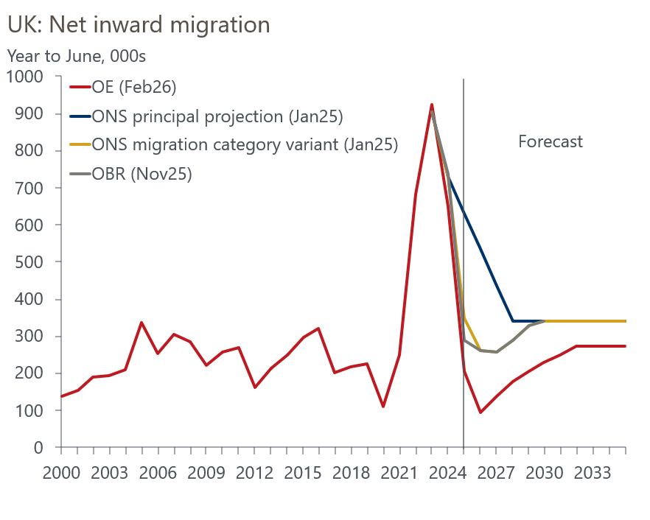
Sources: Oxford Economics, ONS

Given that the Office for Budget Responsibility's fiscal projections are based on an adapted version of the ONS's migration category variant, this implies more fiscal pressures are likely to emerge, as the impact of lower population growth on economic growth and tax revenues begins to show.

Falling immigration is likely to push net inflows below 100,000 this year
A major challenge in analysing demographic trends is that the historical data is in a state of flux. We discuss the challenges presented by data quality concerns in more detail in Box 1.
Immigration fell to 898,000 in the year to mid-2025, from 1.3mn the previous year. This was largely due to sharp falls in the number of people coming to the UK to work and the number of dependents accompanying those coming to work or study, following a tightening of visa criteria by the previous government. Monthly Home Office data suggests visa applications for workers and dependents continued to drop in H2 2025. So while the number of visas granted for study remains relatively resilient, we project that inflows will fall to around 770,000 in the year to mid-2026 (Chart 2).
Chart 2: We expect immigration to fall further this year before stabilising
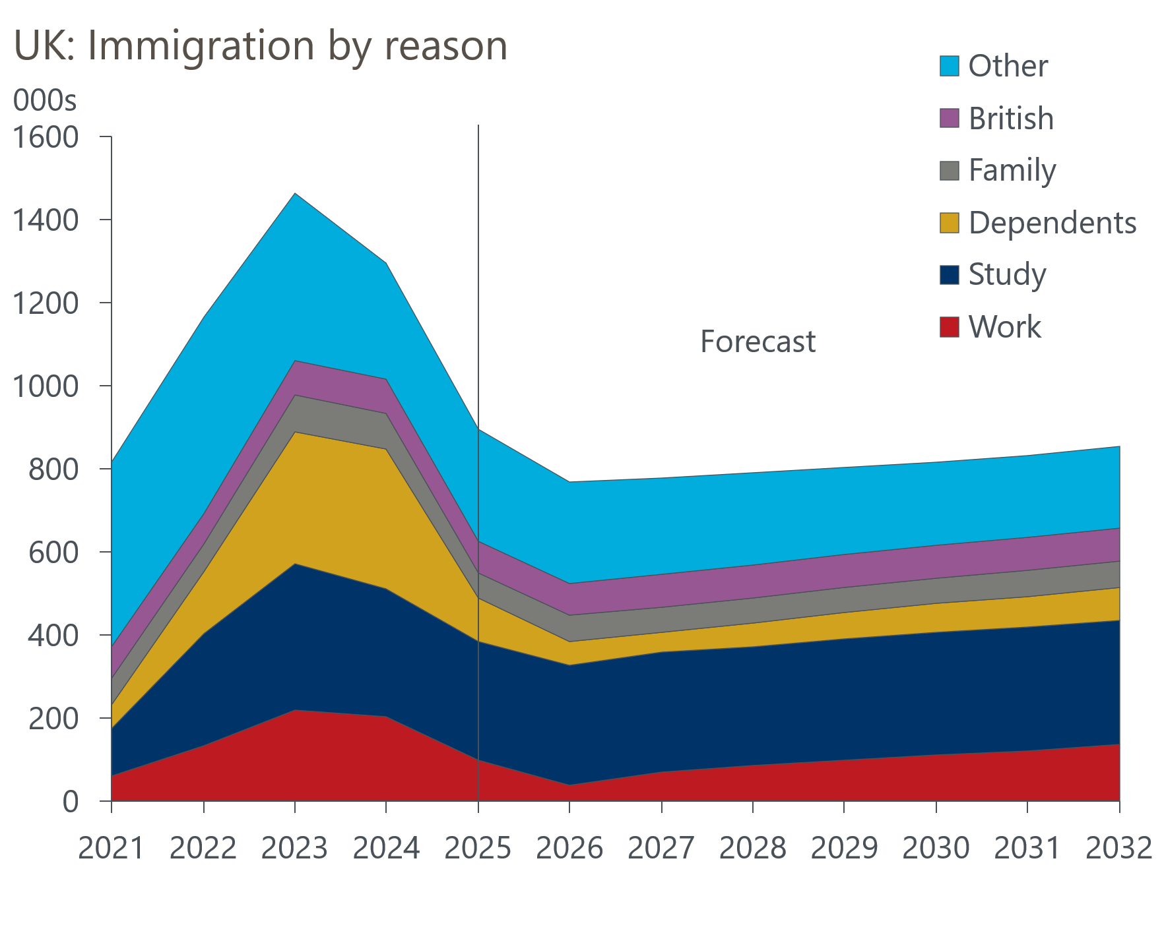
Sources: Oxford Economics, ONS
Emigration has risen sharply in recent years. Fewer people came to the UK to study during the coronavirus pandemic, so it was followed by a period when there were fewer students to return home at the end of their studies. Inflows subsequently recovered and those students are now finishing their courses. But the tightening in visa criteria for dependents has also resulted in outflows increasing in this category.
There's no high frequency data for outflows, so we don't have a good read on this year's likely outturn. While the forces that have driven emigration higher in recent years aren't likely to keep outflows rising, we doubt there will be much of a drop off either (Chart 3).
Chart 3: Though emigration may have peaked, it's unlikely to fall sharply
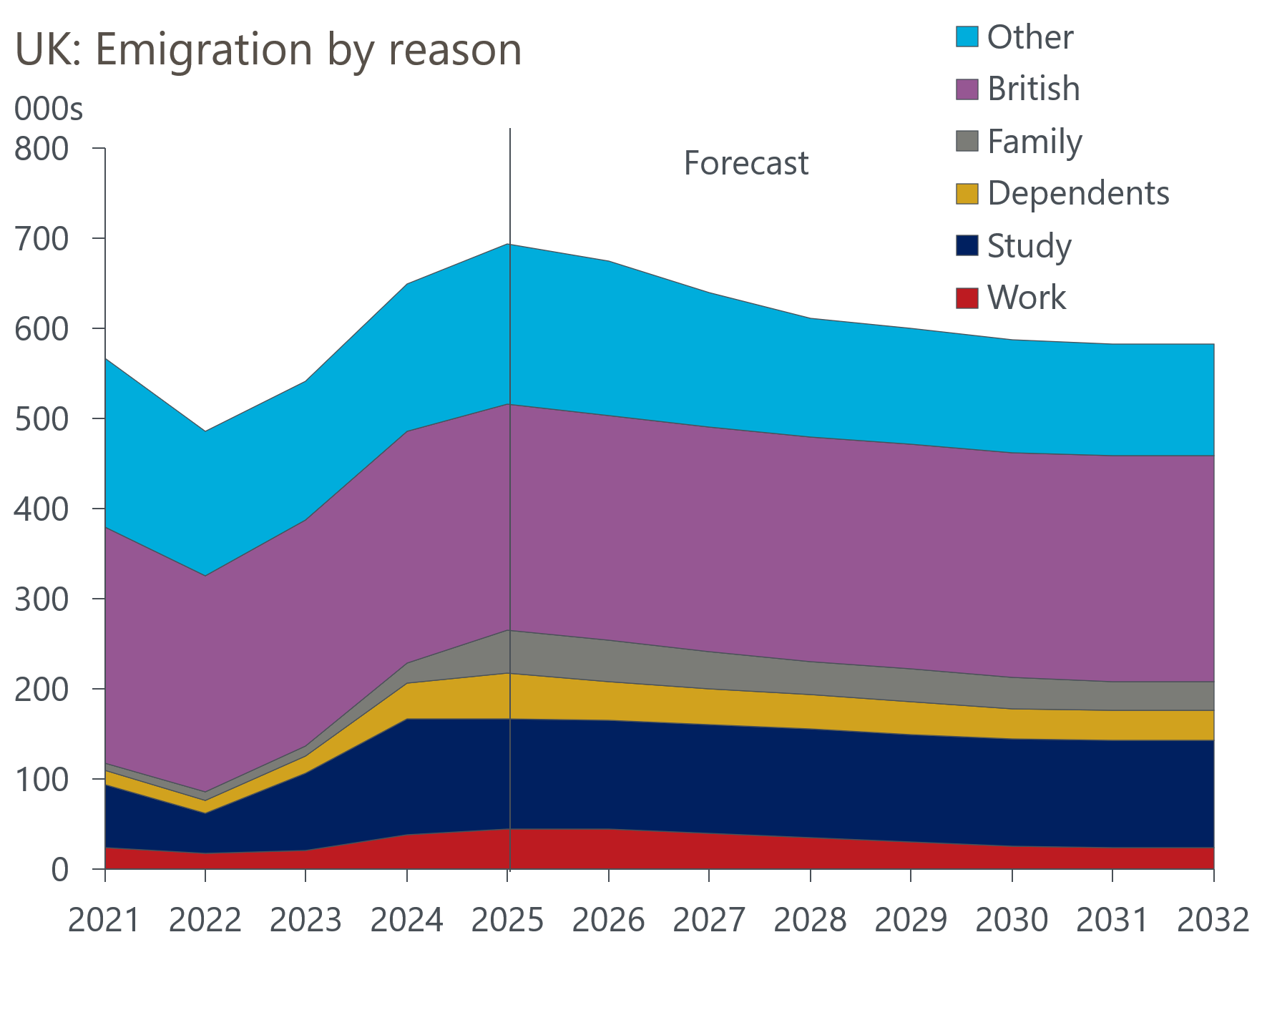
Sources: Oxford Economics, ONS
We assume that the combination of lower inflows and sustained high outflows means that net inflows will drop to just 93,000 in the year to mid-2026. This would be the lowest figure since 1997.

In the current political climate, immigration is likely to remain lower
Despite evidence of a substantial drop in net inflows, the government and key opposition parties continue to advocate reducing levels further. In November, the government presented a white paper on asylum, that proposed making it harder for refugees to settle in the UK permanently. It also announced a consultation on settlement rules, suggesting migrants who entered illegally, overstayed a visa, or claimed benefits would have to wait longer for permanent settlement. Those with permanent status but not citizenship would also find their access to welfare benefits restricted.
While it's hard to quantify the impact that these measures could have, the political climate is consistent with net inflows remaining low for at least the remainder of this parliament. We think 2026 will probably mark the trough of net inflows because the number of people entering the UK for work, to reunite with family, or as dependents, is already very low. And given the reliance of UK universities on fees paid by foreign students, we expect the number of visas issued for study to be resilient.
Nevertheless, our forecast that net inflows will average 169,000 a year from 2026-2030 is well below the 398,000 assumed in the ONS principal projections and 295,000 in its migration category variant (Chart 1). Factoring in the lower levels seen last year, our forecast shows the population 1.5mn (2.1%) lower than the ONS principal projection in 2030, and 660,000 below the migration category variant.

Labour supply growth will be much slower in future
Given the typical age profile of migrants, most of the shortfall is in working age cohorts. This is particularly problematic because the population is ageing, and participation drops off steeply moving up the age distribution. Currently, 19% of the population are over 65, but the ONS projects this cohort will rise to 21% in 2030 and 25% of total population by 2060. Given we think there will be far fewer working age migrants, we expect the age profile of the population will skew upwards more steeply than the ONS estimates.
Increasing the state pension age helps to encourage participation among older workers, and the increase in the state pension age to 67 from 66 over the next couple of years will mitigate the impact of lower immigration in the short-term. But there's only one other single year increase – to 68 between 2044 and 2046 – currently legislated for. There's little scope to change this because of the need to give advanced warning. Furthermore, increasing the state pension age tends to be unpopular with voters, and the febrile political climate in the UK isn't conducive to making this type of decision.
We use a production function approach to estimate potential output (see Box 2 for details). Combining our assumptions for demographics and participation, we expect the contribution of growth in labour supply to potential output to drop to 0.5ppts a year from 2026-2030. In the decade before the pandemic, the contribution averaged 0.7ppts a year.

Still few signs of a productivity improvement
We plan to look at the outlook for productivity growth in more detail in a future report, but so far there is little evidence of a sustained pickup. Since 2019, output per hour has grown by just 0.4% a year, marginally higher than 2007-2019 but well down on the 1.9% a year average from 1980-2007 (Chart 4). The public sector has been a big part of the story: in 2024, public sector productivity was 3.4% lower than it was in 2019.
Chart 4: The UK's productivity performance remains poor
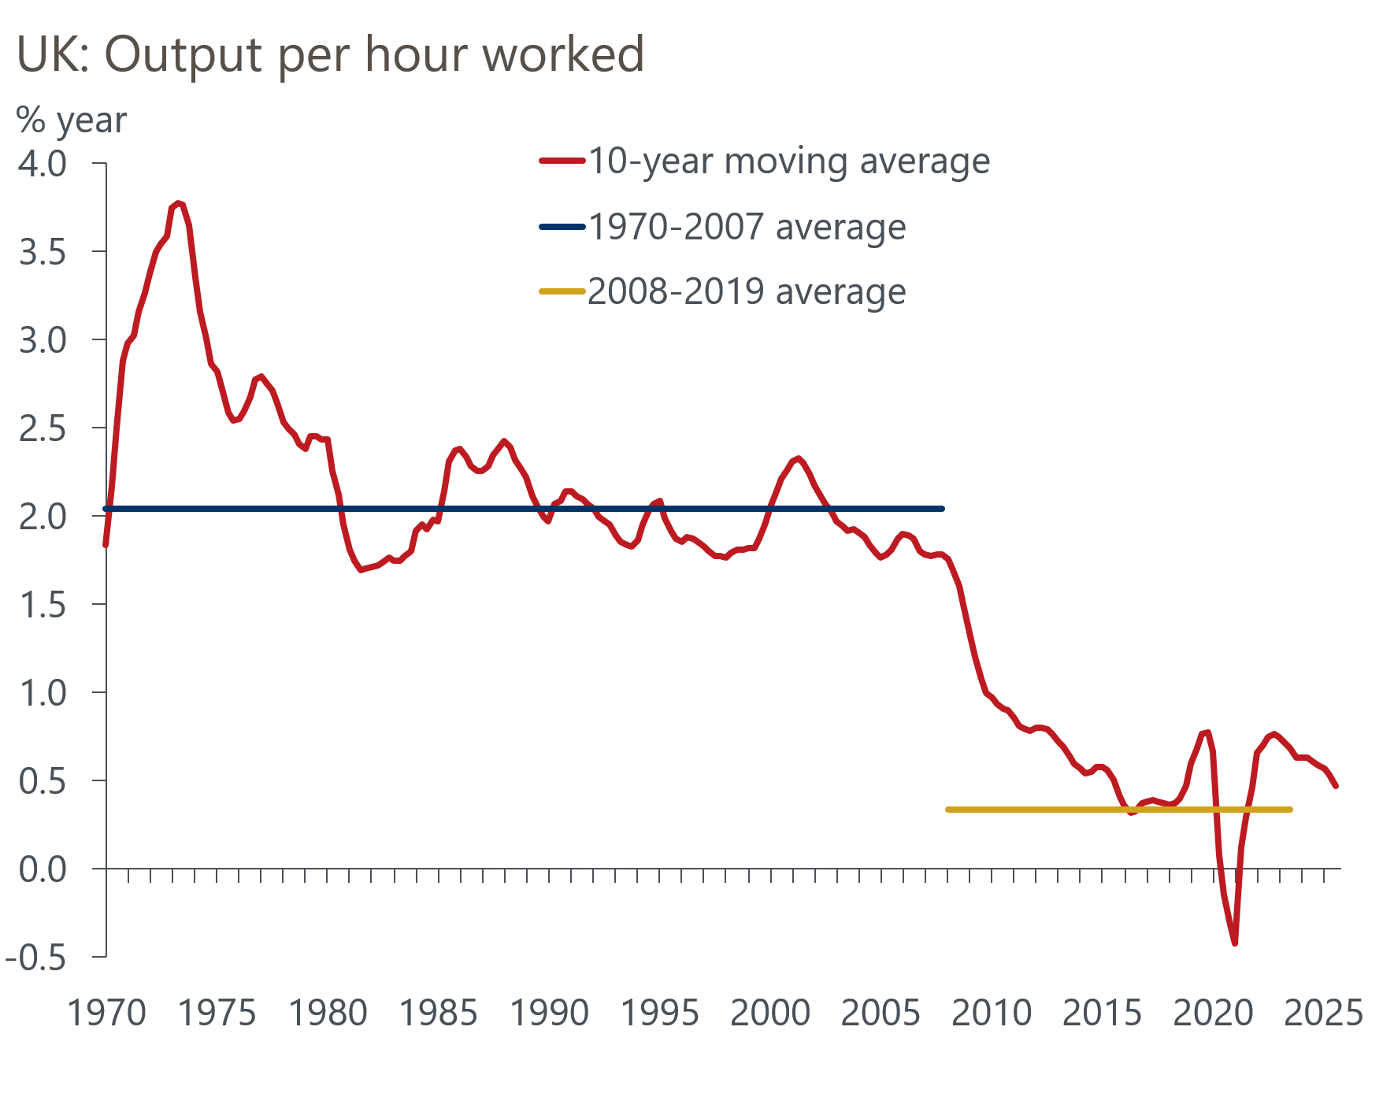
Sources: Oxford Economics, Haver Analytics
Since 2007, the UK economy has endured three huge shocks – the global financial crisis, Brexit, and the coronavirus pandemic – all of which have hurt productivity growth. We expect all three to have large, permanent impacts on productivity levels. But the impacts of the GFC and pandemic on productivity growth are probably now behind us, while a good chunk of the Brexit effects have already been seen. So avoiding further large unexpected shocks should provide a stronger platform for future productivity growth.
AI is a key source of uncertainty. So far, there's little evidence that the UK is reaping significant benefits – there hasn't been the big increase in digital tech investment that’s been seen in the US, nor is the UK a major player in the sectors that manufacture the equipment. There are signs that the UK's data centre sector is expanding rapidly, though there are questions about whether the UK has the appropriate energy capacity to service the sector's needs. On balance, we think AI will offer support to productivity growth, but we're cautious about how quickly the gains will emerge.

Weaker population growth will force the OBR to cut its growth forecast
Combining our assumptions for labour supply and productivity growth, we expect potential output growth of around 1.3% a year for the rest of this decade. We already had a more pessimistic forecast than the OBR because it adopts relatively optimistic assumptions for productivity growth. Our latest revisions, driven by our new demographic assumptions, widen the gap.
We think the OBR will almost certainly have to cut its growth forecast at an upcoming fiscal event to factor in lower population growth. In November, the OBR took on board migration data published since the 2022-based population projections were published last January, but from 2026 onwards it adopted the ONS migration category variant projection. By 2030, our forecast for total population is around 650,000 lower than the OBR's assumption.
The OBR normally bases its forecast on the official population projections, and the next set of projections is due to be published in April. These projections will be 2024-based, so the principal projections are unlikely to fully capture the recent collapse in net inflows. We suspect the ONS will follow recent precedent and produce the equivalent of the current migration category variant projection. If that’s the case, we would expect the OBR to use this as the basis for its forecasts. These changes will likely take effect in this autumn's Budget, but the OBR could flag the likelihood of a downgrade by presenting a low migration scenario in its early-March forecast update.
If the OBR brings its migration assumptions into line with ours, it would imply cutting its potential output forecast in 2029-2030, the target year for the fiscal rules, by around 1ppt. Applying this change to the OBR's ready reckoner suggests it would add around £19bn (0.5% of GDP) to borrowing on the current budget measure in 2029-2030, wiping out the bulk of the Chancellor's margin for error.
In the near-term, we think the monetary policy impact of lower net inflows will be limited. Given the relatively short time horizon of the Bank of England's forecasts, it typically treats lower population growth as roughly offsetting negative shocks to demand and supply.

Potential output growth will become increasingly reliant on productivity gains
Our longer-term forecasts assume that net inward migration settles at around 270,000 a year, above current levels but 20% lower than official projections. This would be sufficient to ensure labour supply growth continues to contribute positively to potential output growth over the next few decades. But those contributions will gradually fade as the population ages, and by the 2050s we expect labour supply growth to contribute less than 0.1ppts a year to potential output growth (Chart 6).
Chart 5: Our baseline forecast shows an increasing reliance on productivity growth
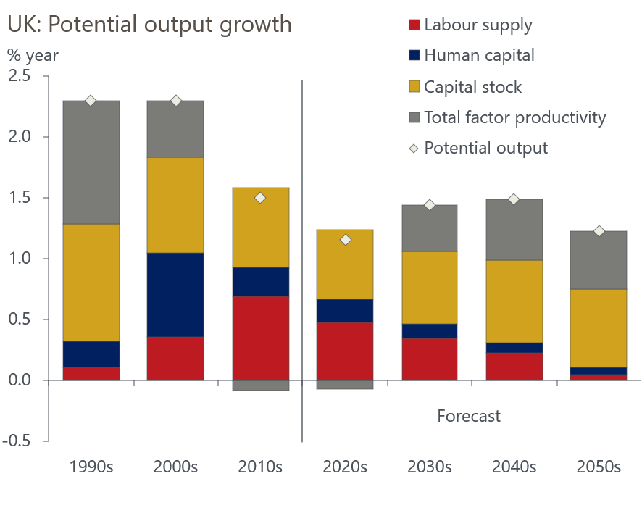
Sources: Oxford Economics, Haver Analytics
We're also much less optimistic than the OBR over the longer-term: by 2060 our forecast for the level of GDP is 15% lower than the OBRs (Chart 6). Our long-term assumption for net inward migration is slightly lower, resulting in softer labour supply growth. But the main difference is on productivity. The OBR assumes that that productivity growth moves closer to long-run historical norms than the experience of the past 15 years. This assumption is not implausible, particularly if the gains from AI adoption and investment in climate change technologies begin to emerge quickly. But it looks optimistic in the context of the much weaker productivity growth since the global financial crisis.
Chart 6: Our long-term growth forecast is more cautious than the OBR's
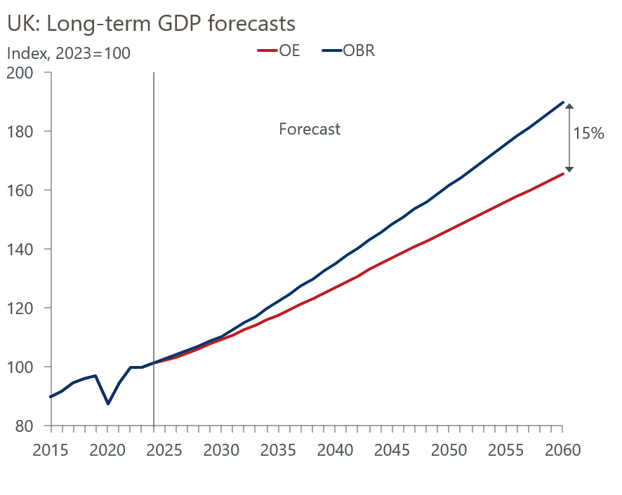
Sources: Oxford Economics, Haver Analytics
In its annual fiscal risks and sustainability reports, the OBR has highlighted the vulnerability of the UK's public finances. The 2024 version carried particularly stark warnings about the trajectory of government debt under current policies given the rising costs of looking after an ageing population. If we're right and the OBR is too optimistic about the long-term growth outlook, those problems will be even more acute.
But long-term forecasting is inherently uncertain, and the demographics part of the story can be particularly hard to pin down given the importance of immigration policy. We plan to extend our research with another report that looks at the impact of different assumptions for net inward migration on the outlook for long-term growth and the public finances. One of our alternative scenarios will look at zero net migration and a global version of this scenario will also feature in our next Megatrends Scenarios release in April.

Box 1: Significant concerns over the quality of population data persist
Of the many areas where the ONS is having problems collecting reliable data, the issues with the population data are among the most serious. In recent years, the statistics office has introduced a series of methodological improvements, and the move to using administrative data instead of surveys should improve reliability. But for some key indicators it leaves us with truncated or inconsistent time series.
In some cases, there's no pre-pandemic data. Given the extent to which the pandemic and special visa schemes for migrants from Ukraine and Hong Kong have influenced migration levels in recent years, the lack of a pre-pandemic benchmark makes calibrating forecasts even more challenging, The changes will also mean that datasets that rely on population data as inputs, such as the Labour Force Survey, will also be subject to revision.
The latest estimates of emigration are much higher than the previous vintage published by the ONS. This reflects the introduction of methodological changes that suggest much higher levels of British and EU+ (EU countries plus Norway, Iceland, Liechtenstein and Switzerland) nationals leaving the UK each year.
But the new methodology is still quite speculative. The estimates of movements of British citizens are based on individuals' interactions with the tax and benefits system – on the emigration side, in particular, this relies on the ONS making numerous assumptions about people not covered (e.g. children and students) and whether those no longer paying tax or receiving benefits have left the UK or not.

Box 2: A production function approach to estimating potential output
We use a production function approach to estimate potential output. This provides a framework that relates the level of potential output to contributions from factor inputs – labour, human capital, and capital – and the efficiency with which those inputs are used (‘total factor productivity’).
It also provides a consistent method for forecasting future growth in potential output, taking into account important changes such as demographic trends.
Potential output is calculated as:
ln(Y*) = 0.65ln(L) + 0.3ln(H) + 0.35ln(K) + ln(A)
where:
Y* is potential output.
L is potential labour supply, which is equal to the labour supply at the non-accelerating inflation rate of unemployment (NAIRU) multiplied by average hours worked.
H is human capital, which is defined as the average years of education in the working age population.
K is the capital stock.
A is total factor productivity (TFP).

